# **UserManual**

## *for Call DOCTOR*

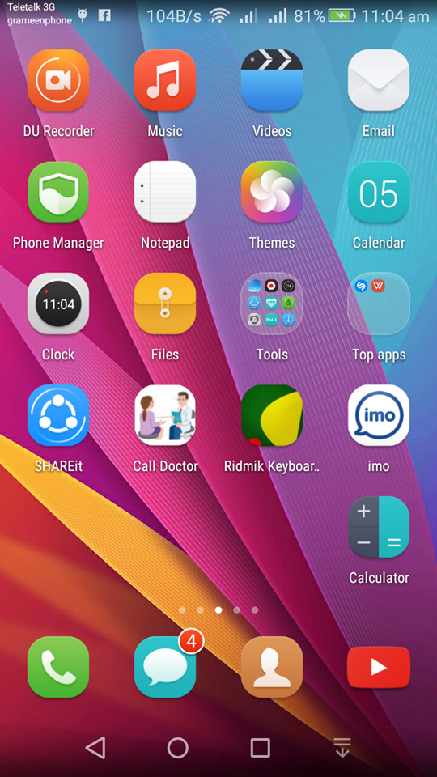

Call Doctor app in the android mobile

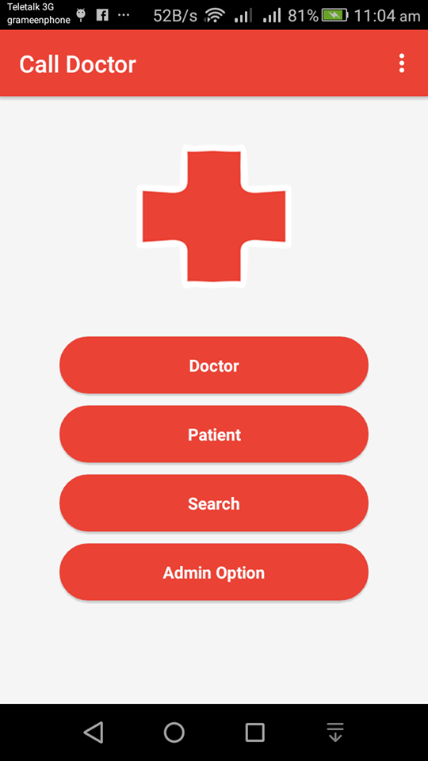

After clicking in the APP we can see four options

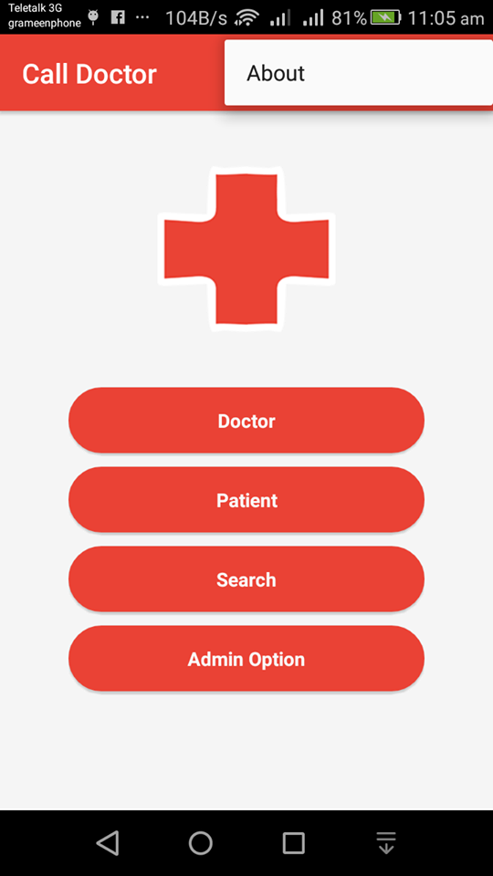

By clcicking on the right corner

We can see about button

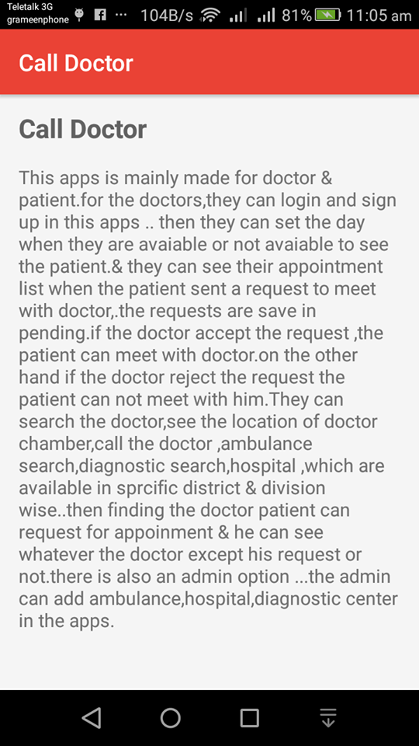

Here is the app details

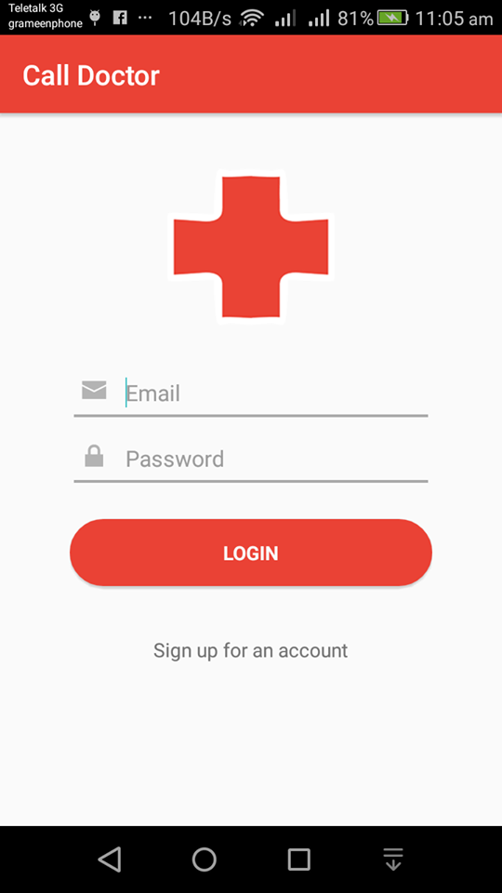

By clicking on doctor button, the doctor see this page. If he is not registered he have to click “sign up for account”

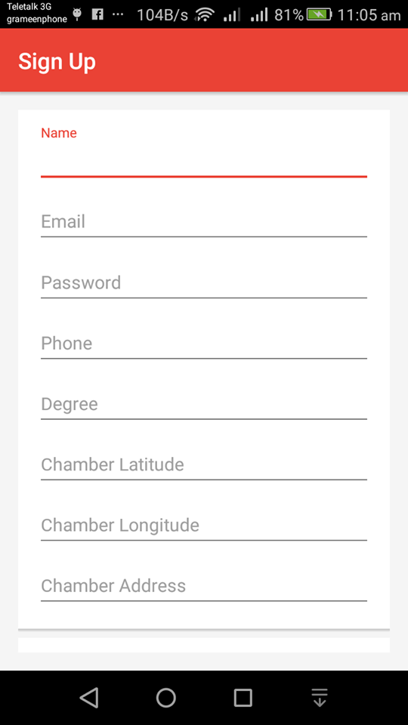

By clicking on he have to fill up all the fields



After sign up , a doctor can login his account

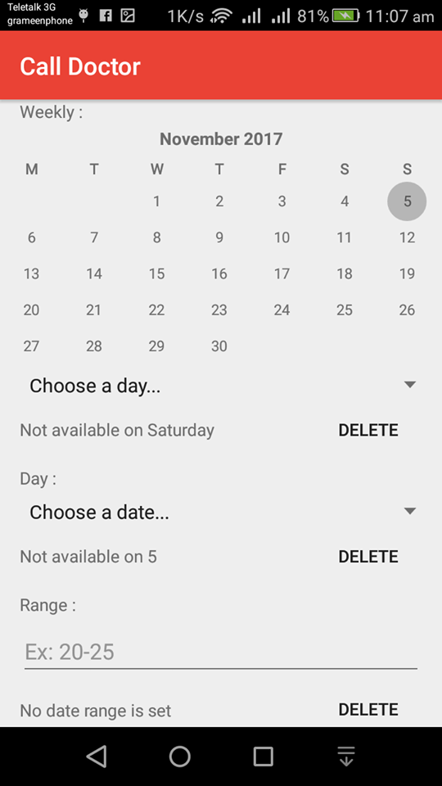

Here a doctor can set in which date he in unavailable.

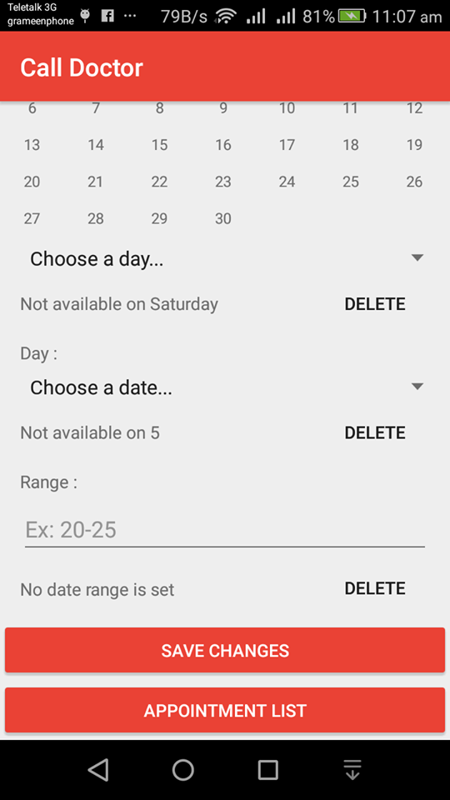

By clicking “APPOINTMENT LIST” a doctor can see the patient who want to meet him

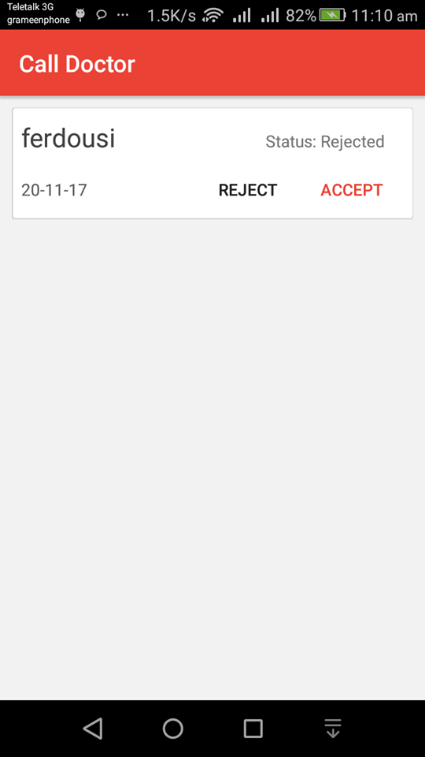

Here is the appointment list

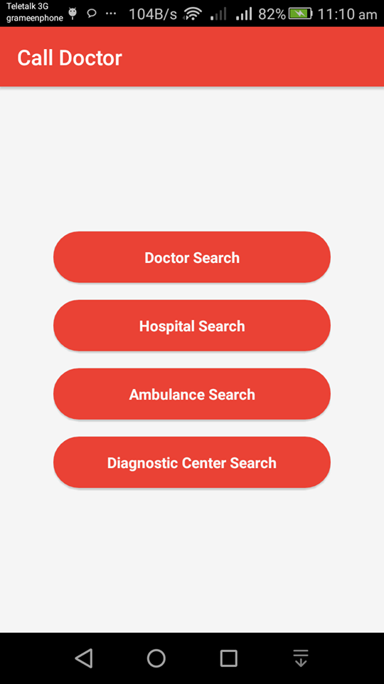

Here is the Search options

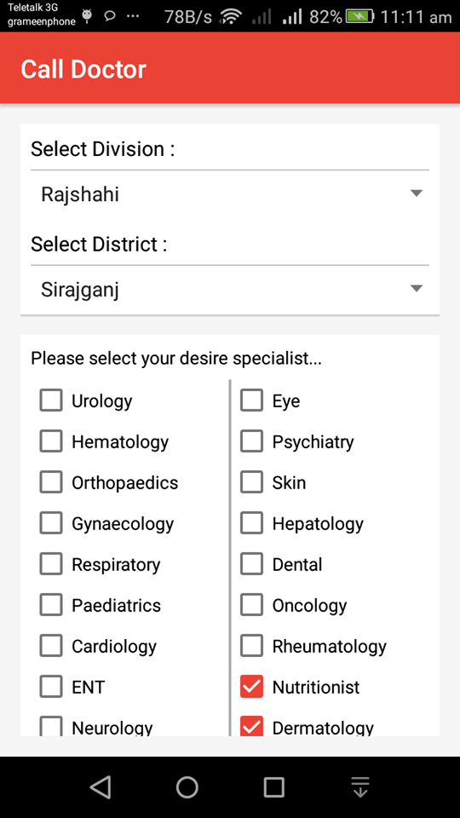

By clicking “Doctor Search”

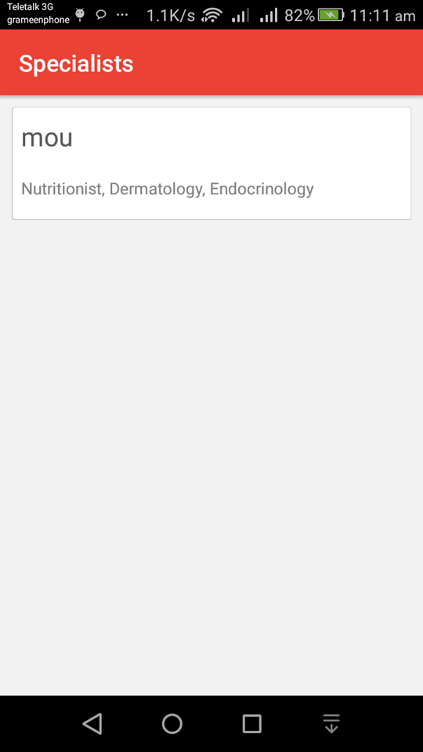

By searching we can see the doctors name and in which he is specialist 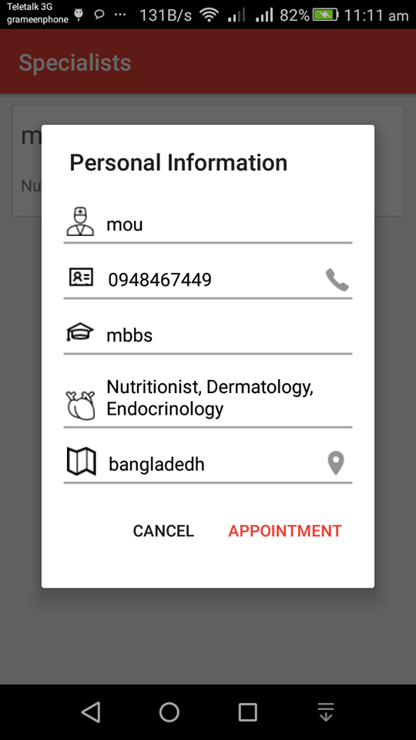

Here is the doctor details

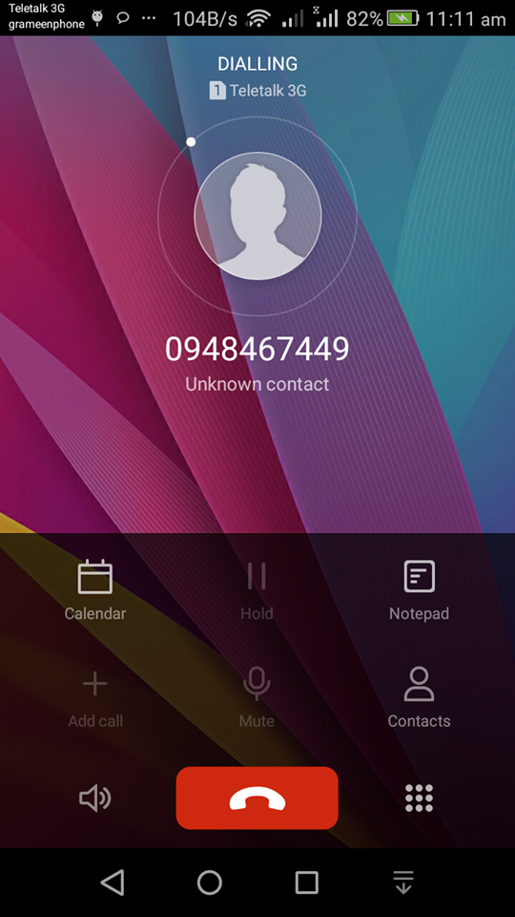

From here we can call doctor

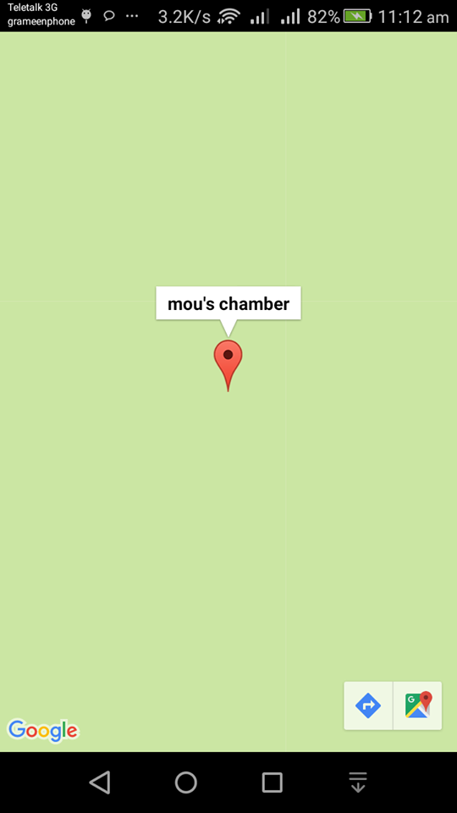

From here we can see the location in the goggle map

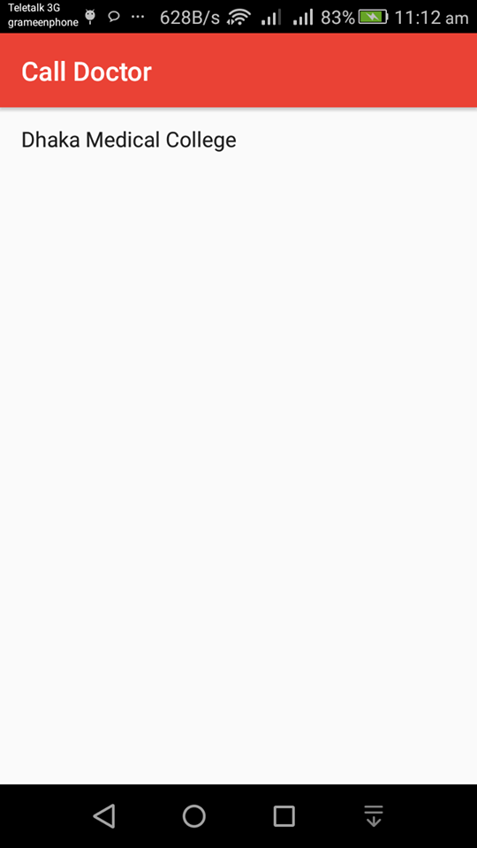

After clicking Hospital Search

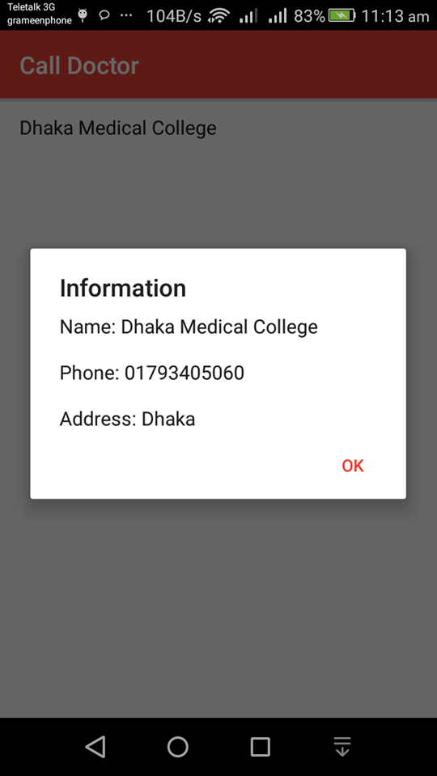

Here we can see Hospital details

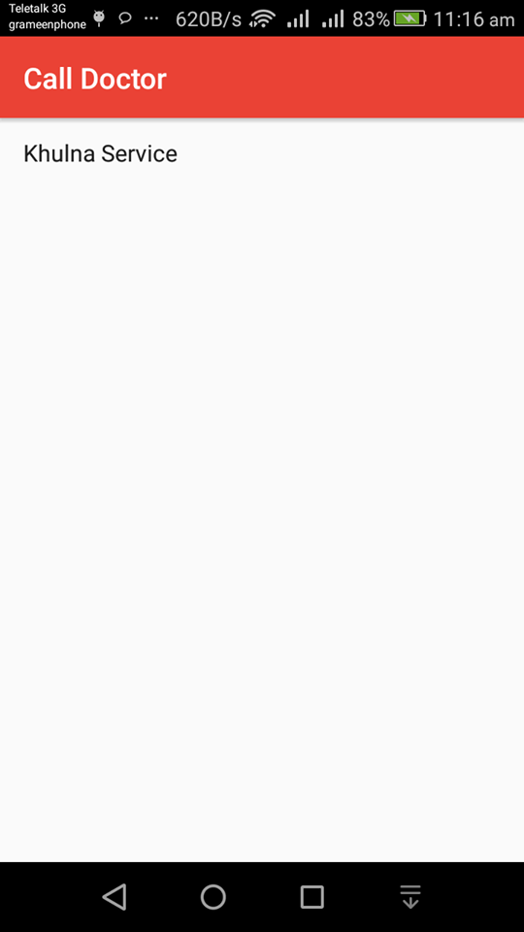

After clicking Ambulance Search

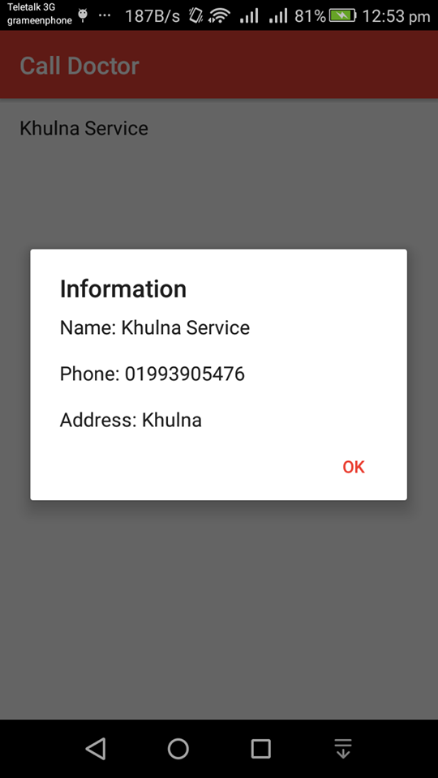

Here we can see Ambulance details

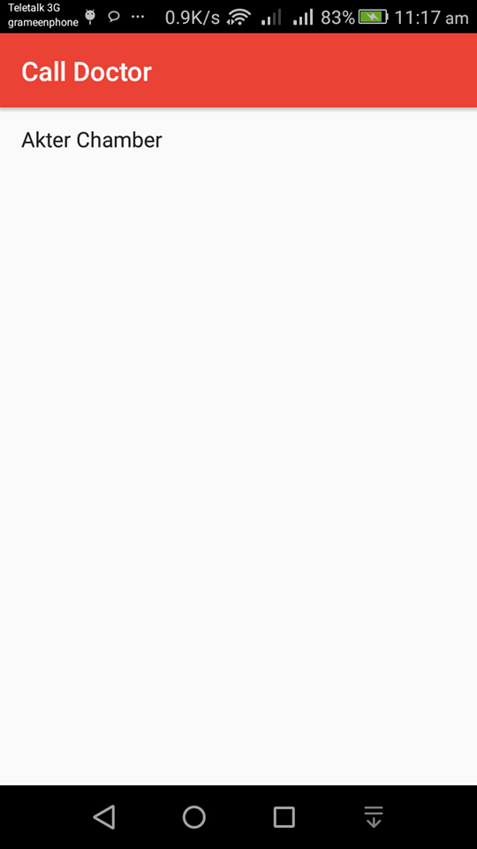

After clicking Diagnostic Center Search

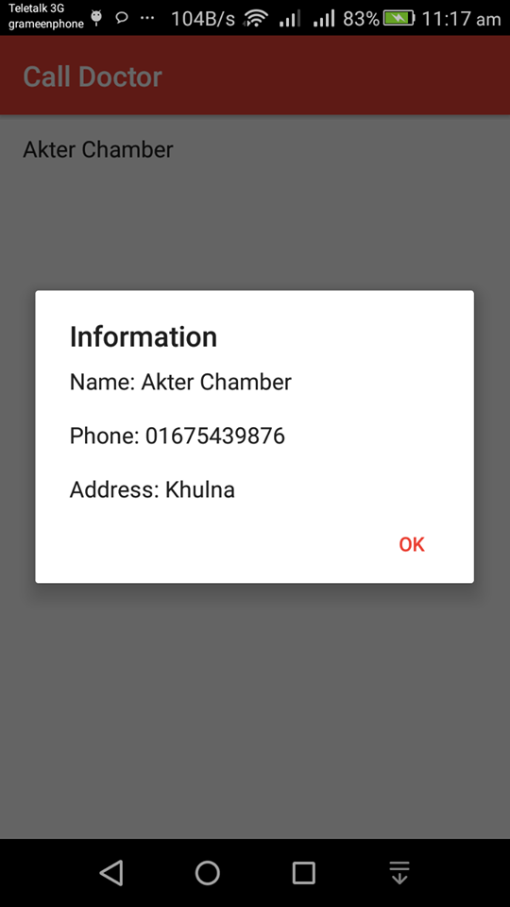

Here we can see Diagnostic Center details

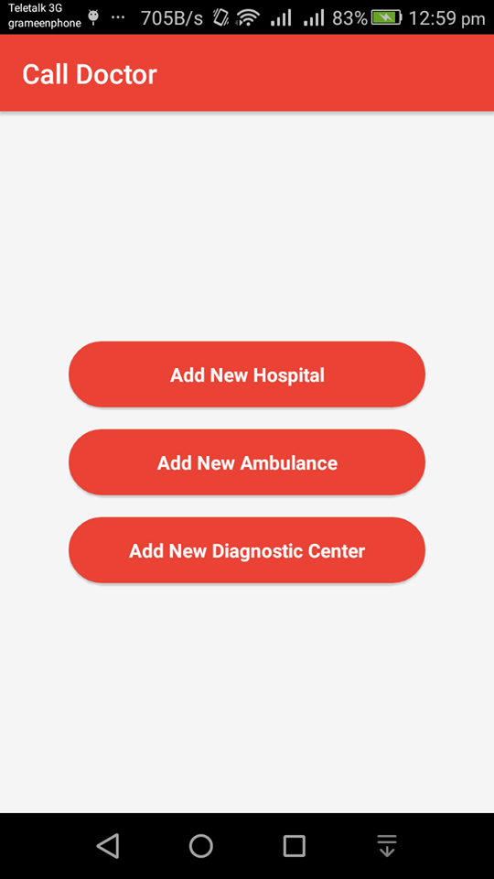

After login in Admin,

The admin can see the options

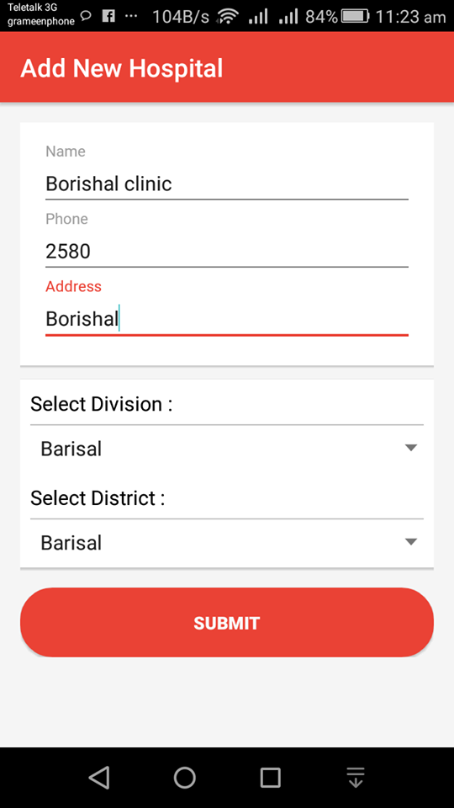

Here the admin can input hospital, Ambulance, Diagnostic center in the same way